Novice and Rookie Youth and Amateur Reserve All-Around
Mac Sport Wagon
Built on a solid steel frame, it is covered in durable red polyester fabric. This handy wagon folds into its own carrying bag for easy, compact transport and storage.
Dimensions (Overall): 22.52 inches (H) x 20.2 inches (W) x 35.51 inches (L)
Weight: 21.78 pounds
Holds up to: 150 pounds
Material: Plastic
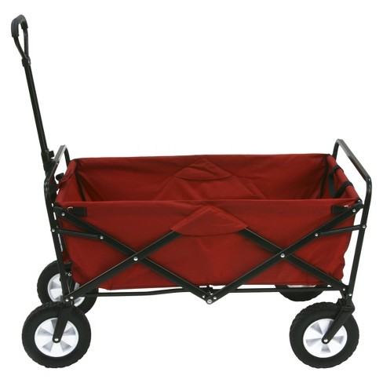

High Point Mare, Gelding, Stallion
Duo-fit insulated show cover
Features include:
- 420 denier breathable nylon outer is contoured through the hip for a great fit
- 220gm of mid-weight insulation adds warmth in transitional weather
- Soft, maintenance free nylon lining keeps coats shiny and smooth
- Attached neck can be opened independently from the body to maintain bands and braids without uncovering your whole horse
- Ideal for Halter or Showmanship horses and can be used over tacked horses at ringside
- 2 velcro straps at chest, 3 velcro straps at the neck, and 1 velcro halter tab
- Adjustable girth strap and detachable, elastic leg straps keep show cover in place
- D-ring at withers for hanging or for attaching halter tab when neck is folded back
- Color: Black with Gray binding
- Sizes: Medium (68-74), Large (76-80), X-Large (82-86)
- 