2018 Reserve Class Champions
Adjusta fit Dura Nylon V-free Closed Front Sheet with Tail Cover
Schneiders # 17287
Dura-Nylon® sheets are great for maintaining the coat, keeping your horse clean and work well as blanket liners. Breathability keeps your horse from over heating.
- Closed front with adjustable reinforced web leg straps & front girth strap
- V-Free® pressure free wither design ("patented" feature)
- Attached tail cover
- 420 Denier Breathable Nylon
- Color: Navy
- Sizes: 64, 68, 70, 72, 74, 76, 78, 80, 82, 84, 86 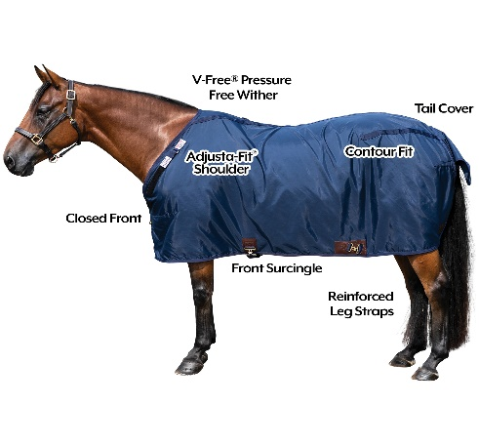
Adjusta fit Dura Nylon V-free Open Front Sheet with Crisscross Surcingle
Schneiders # 10552
Dura-Nylon® sheets are great for maintaining the coat, keeping your horse clean and work well as blanket liners. Breathability keeps your horse from over heating.
- Open front with crisscross surcingles
- V-Free® pressure free wither design ("patented" feature)
- Detachable elastic leg straps
- 420 Denier Breathable Nylon
- Color: Green or navy
- Sizes: 68, 72, 74, 76, 78, 80, 82, 84, 86
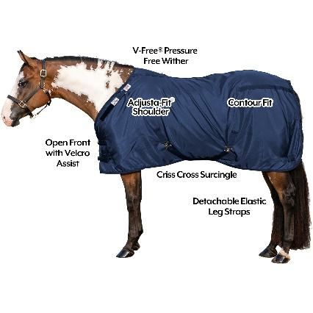
Saddle Caddy Wheeler
Schneiders # 25355
- Constructed of 1” galvanized steel tubing
- Folds flat for easy transport or storage when not in use
- 8” hard rubber wheels require no maintenance
- Sturdy enough to hold the heaviest Western saddle
- Western saddles should be positioned with the cantle end against the front loop
- Removable lower basket holds grooming supplies
- Rolls easily across most ground surfaces
- Industry leading 5 year warranty against breakage or defect
- Dimensions:
Rack Height 31”
Rack Width 11”
Total Length 32”
Wire Basket 17.5” Long, 9.5” Wide, 13” Tall
Wheels 8”

