2018 CLASS CHAMPIONS:
Black Midweight winter blanket. Adjusta-fit Super Quilt V-free Leg strap Stable Blanket.
Schneiders # 36566
Featuring the "Original" Adjusta-Fit1® System
- Durable 1200D SuperQuilt® outer cover
- V-Free® pressure free wither relief (patented feature)
- Adjustable reinforced web leg straps & front girth strap
- 1200 Denier Breathable Polyester Outer / Midweight (280gm) Insulation / Breathable Nylon Lining
- Lifetime Guarantee.
- Color: Black
- Sizes: 68, 70, 72, 74, 76, 78, 80, 82, 84, 86
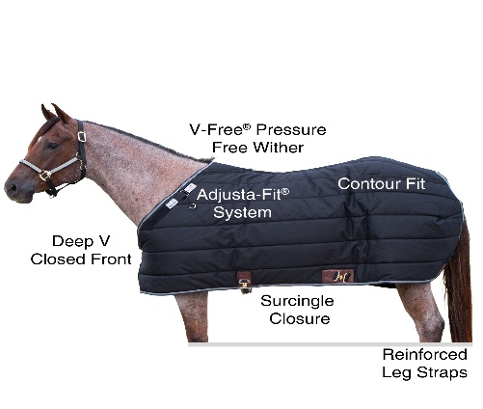

Schutz Brothers 5/8” Quick Change End Harness Leather Reins Rods #7022 